**Connecting to ScreenBeam with Windows**

**Press the windows key on your keyboard and the K key at the same time**

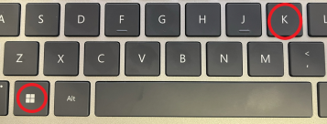

**That will bring up rooms that you can connect to**

**Select your room, then enter the code you see on the screen**

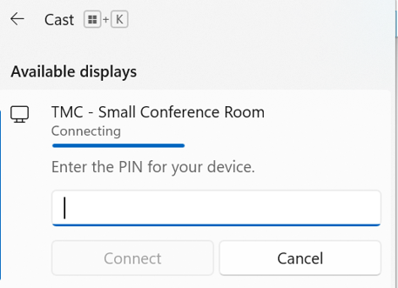

**You may need to press windows K again to see the code field**