Logging in
- Username is firstnamelastname with no space
- For example: leighdaul
- Password is your district password
- If someone else has logged into the computer, select “Other user” in lower left corner

Changing password
- To change your district password:
- While on the school network: press Ctrl Alt Del
- Select “Change a password”
- Enter your old password, then the new one

- If you need or want to change your district password when off our network:
- Go to an Office 365 website such as: outlook.office.com or portal.office.com
- Log in with district email and password
- In the upper right corner, select the circle with your profile picture or initials
- Select “View Account”
- Then select “Change Password”
Changing your password off network changes your district password but you’ll need to use your old password to log onto the computer until you get back on the school network.
Tips for a strong password
- Long passwords are stronger, so make your password at least 12 characters
- Use upper and lower case letters as well as numbers and symbols
- Make a password from the first letter of each word in a sentence
- Don’t use names from your life such as children or pets
- Don’t use important dates such as birthdays or anniversaries

Finding applications
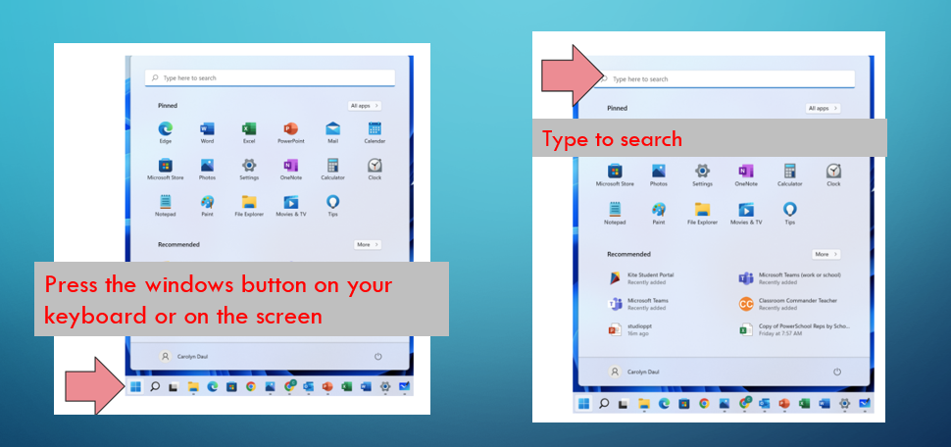

Installing applications
- Find the application: Software Center
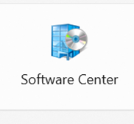
- Select an application and install
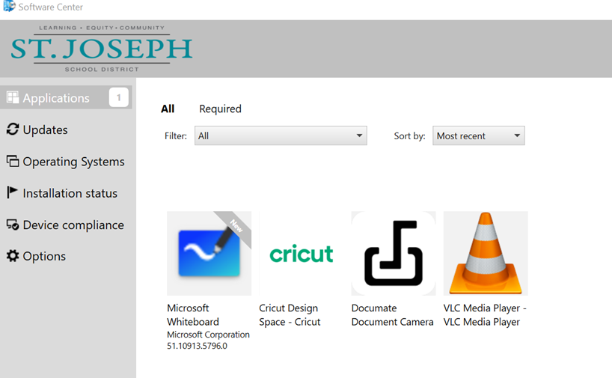

- If you don’t see an application that you need, put in a help desk request by emailing helpdesk@sjsd.k12.mo.us or submitting a ticket at sjsdhelp.zendesk.com

Where to find files

- File explorer is like Finder on Mac
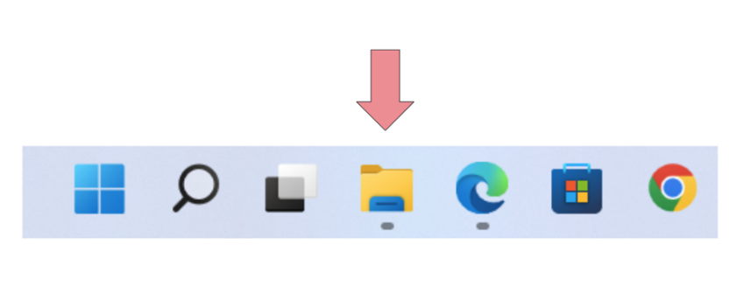
- We recommend saving files to a cloud drive such as One Drive so if you ever lose your computer, you don’t lose the files

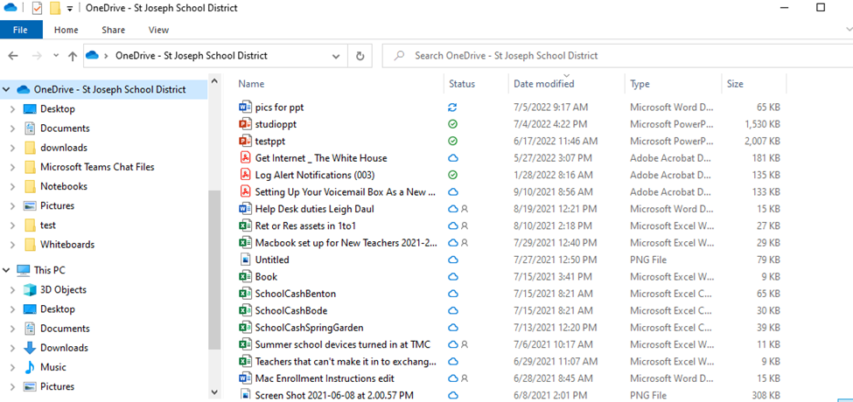

- One Drive is already installed on your laptop, you just need find and open the application and log in.
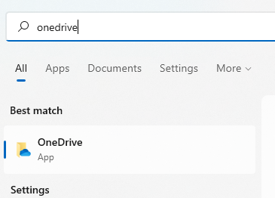
Enter your email address and Sign in
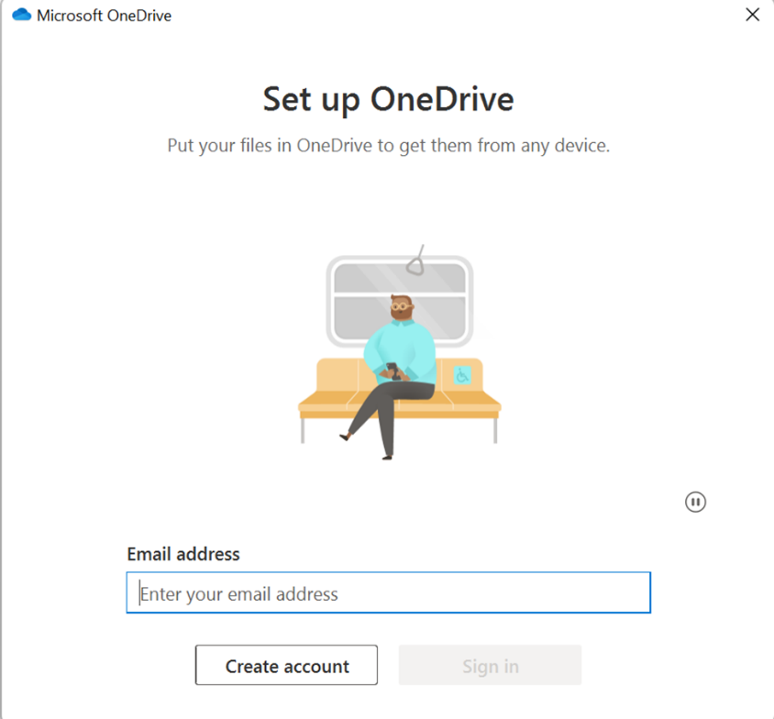

Select “Next”
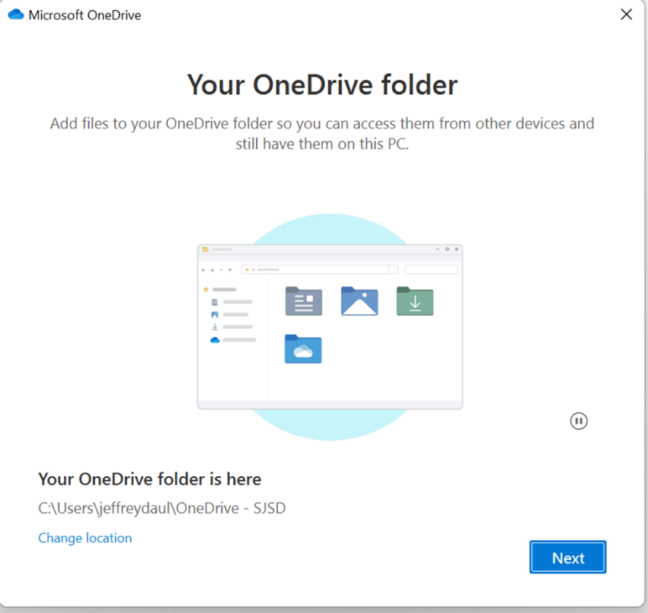
Keep default settings and Continue
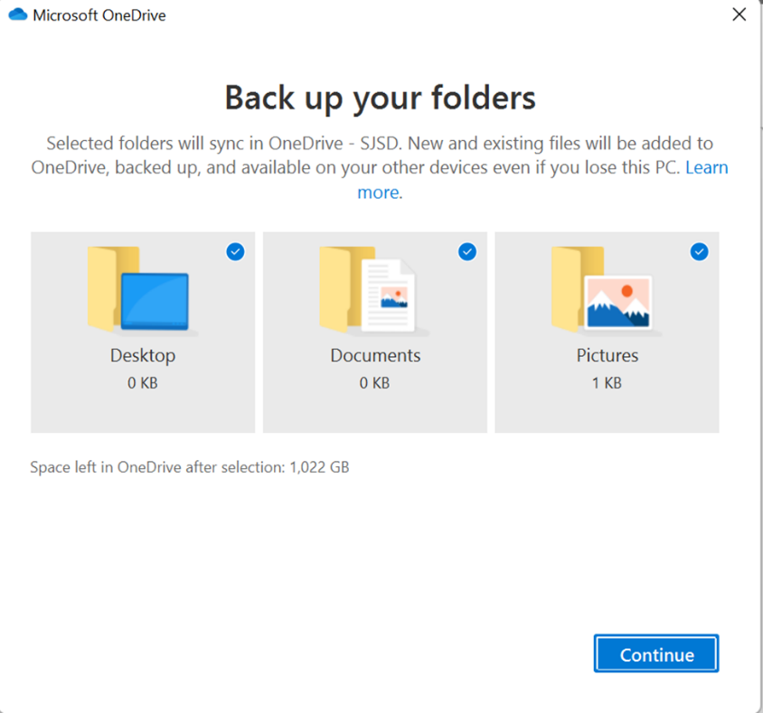
Select “Next” on the following screens 

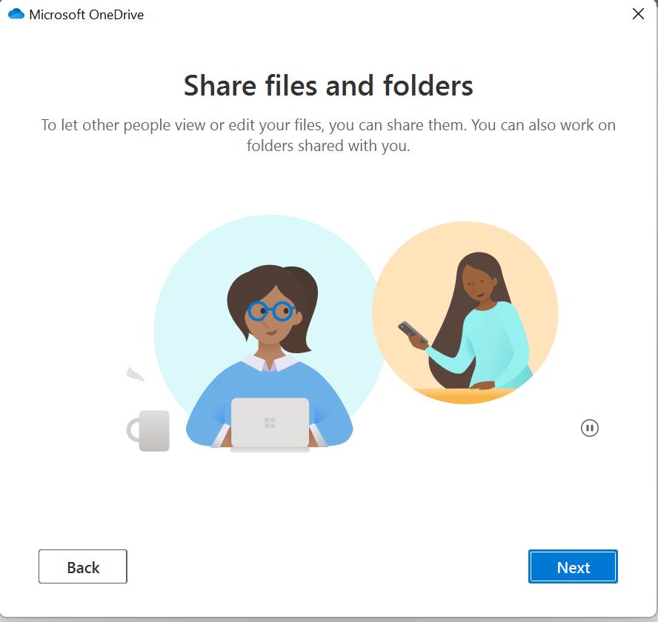

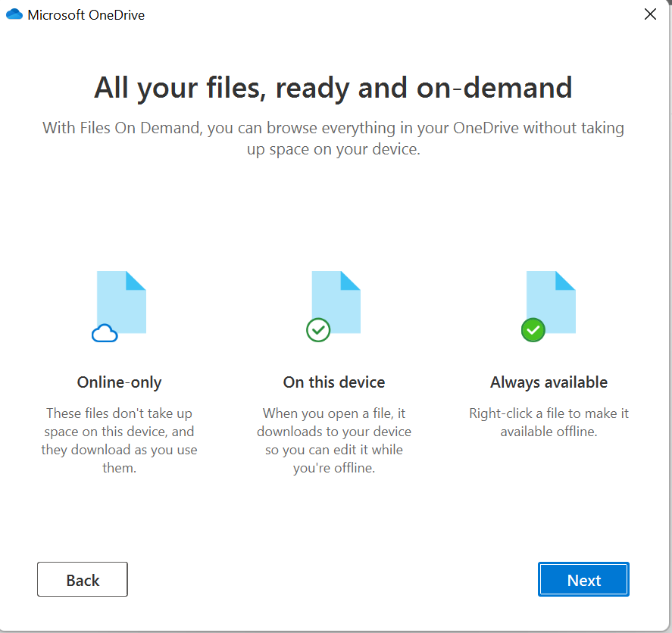
You can select “Later” on this screen
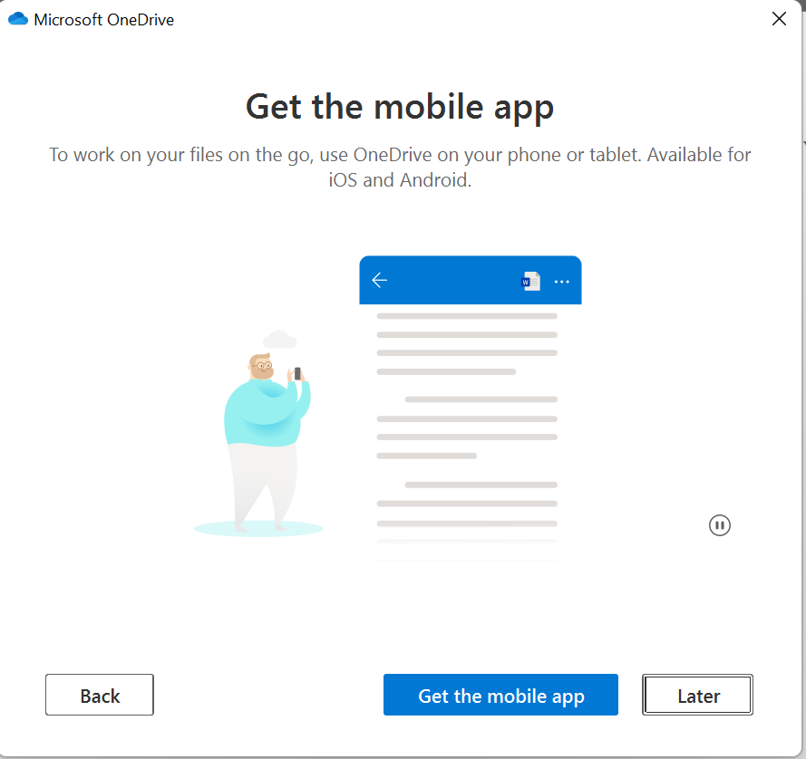
Select “Open my OneDrive folder”

How to restart the computer
Press the windows button on your keyboard or task bar
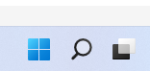
Click the power button and you’ll be given options to Sleep, Shut down, or Restart
