**Faxing Instructions with VoIP System**

**Secure Cloud Fax**

**PLEASE USE THE REGULAR SCAN TO EMAIL FEATURE ON THE PRINTER/COPIERS AS OFTEN AS POSSIBLE/FEASIBLE RATHER THAN SENDING AS FAX.  WE PAY FOR FAXING, BUT WE PAY NOTHING FOR REGULAR SCAN TO EMAIL.  REGULAR SCAN TO EMAIL IS THE SAME AS THE INSTRUCTIONS BELOW, EXCEPT YOU SEND TO AN EMAIL ADDRESS RATHER THAN A FAX NUMBER WITH “SECURE CLOUD FAX” AT THE END.**

**Outbound Faxing Instructions**

* Go to any Savin Copier/Printer with a card reader
* Place the document you want to fax on the scanner tray on the top of the machine
* Login (swipe your badge)
* Select Scanner from screen

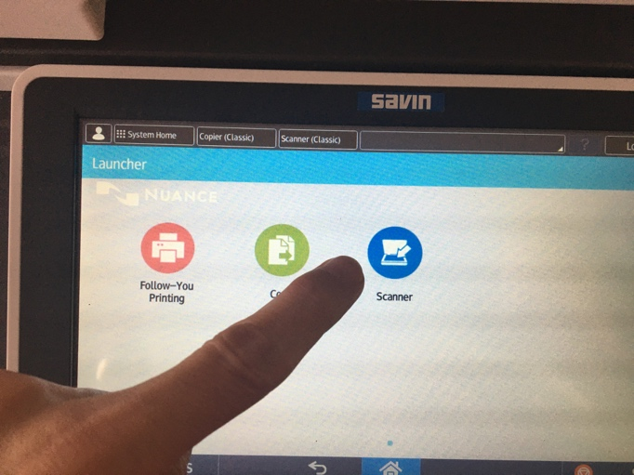

* Choose “Specify destination”

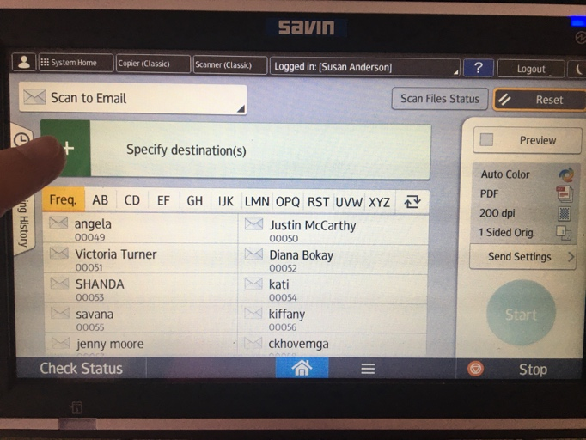

* Choose “Enter Using Keyboard”

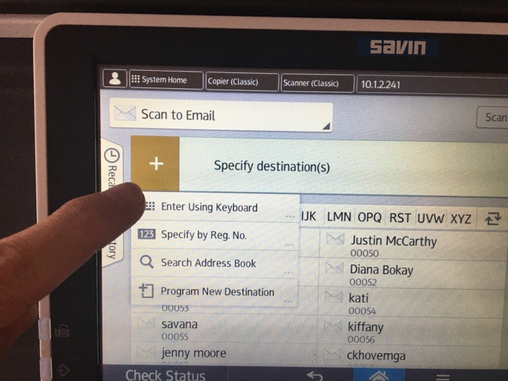

* Using a combination of numbers and letters, enter the phone number to which you want to fax and add “@securecloudfax.com” at the end
  + E.g. [19135446677@securecloudfax.com](mailto:19135446677@securecloudfax.com)
* Once the number is entered, click “Done”

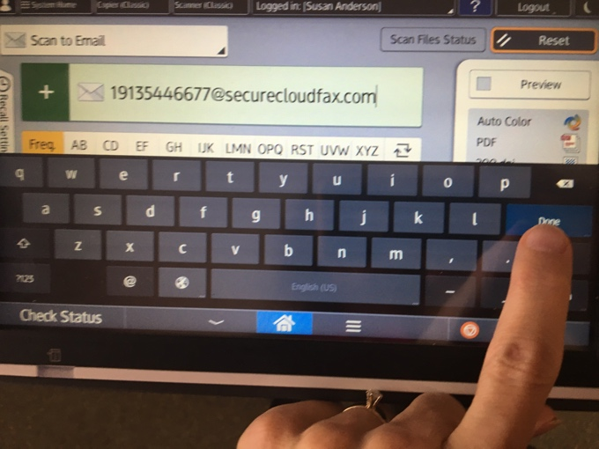

* Click Start to send your document via fax

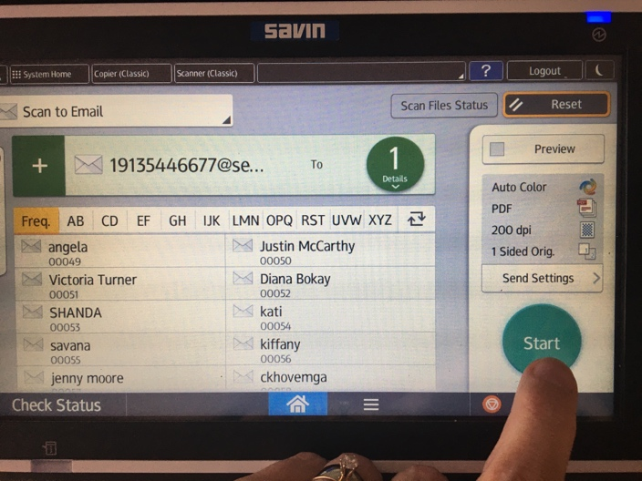

**Inbound Faxing Instructions**

* For each fax number, a few people in the department will receive inbound faxes in their email (we can adjust who in the department receives the inbound faxes)
  + Please forward to the appropriate person in the department or delete if “junk” fax